

**Weekly Phone Blasts**

Parents will be receiving weekly phone blasts (calls) to keep everyone aware of upcoming events. Please contact the school if you are not receiving a call every Sunday at 5:00 p.m.

# I-Ready Superstars

Week of 12/9/13

Reading- JaJuan McKinnon (10 lessons)

Math- KeAri Funches (9 lessons)

# AR Superstars!

**Ms. Liput Mrs. Williamson**

Laneesha Anderson Jayla Dillard Walker

DeAnna Hooper

Caityn Tucker

**Mr. Goodwin Ms. Dearman**

Charre Anderson Sherrion Green

Alyssa Colister

Cristofer Godinez

Sharrion Green **Ms. Dammer**

Areyelle Greene Kaniah Thompson

Kristian Hurt

Arjel Matthews

Anthony Owens

**Mrs. Washington Mr. Williams**

Aracely Cervantes Jonathan Castellanos

Anthony Dezhda Aailah Hampton

Nyla Robinson Trevell McKinnon

# Students of the Month

Classroom Student

Ms. Dammer Terrell Arrington

Ms. Dearman Aliyah Jiggets

Ms. Jacobs Mia Mareci

Mr. Goodwin Eric Jenkins

Mrs. Kelly Timmy Mareci

Ms. Liput Jaylyn Whitfield

Mrs. Phillips Amiya Seals

Ms. Smith Clyde Adams

Mrs. Washington Shandale Fair

Ms. Weglarz Victoria Ramirez

Mr. Williams Caleb Obadele

Mrs. Williamson Trinity Collins

CCII Briana Mondane

Please join Markham Park in recognizing our students who have excelled this month! We are very proud of them!

Greetings,

I would like to send a huge THANK YOU to our Parent Teacher Organization (PTO); they helped make our winter celebrations a huge success!

WELCOME BACK! I hope you all had a fine break and are looking forward with enthusiasm to the rest of this year.

I want to remind parents to complete EAGLEBUCKS (located in a labeled box across from the office) every time you attend a school function. We gave away gift cards for the first quarter. We plan to announce our second quarter winner at our Black History Program scheduled for February 12th. Our prizes have increased, so we would love for our attendance to increase as well. Please check our website and monthly newsletter for upcoming events. We hope and trust that you will find our evening programs to be both interesting and informative.

Thank you for your continued support and assistance.

Deloris Alderson

Principal



# Principal’s Platform



Markham Park School

Markham, Illinois

January 2014

Volume 5, Issue 1



eight years. She is a welcoming, hardworking individual who helps so many students, parents, and staff members from the time they walk in the door to the time they leave. She is efficient and organized in her duties. Mrs. Solomon-Cropes is married, is the mother of four children, and also has one grandchild. Her hobbies include playing and coaching basketball, shopping, travelling, and spending time with her family. She helps out with all the committees at Markham Park School in some way, and she also assists with Grandparents’ Day and Career Day. She is an integral part of the Markham Park team. Congratulations, Mrs. Solomon-Cropes, on your Support Staff of the Month recognition!



# Mrs. Solomon-Cropes

Mrs. Solomon-Cropes is Markham Park’s Support Staff Member of the Month for December. Mrs. Solomon-Cropes is the administrative assistant at Markham Park and has worked in District 144 for

He also encourages them to work together and he strives to build each student’s integrity. He is married with two children and also has two grandchildren. Mr. Williams’ hobbies include roller skating, playing dominoes, and playing Playstation 3 and 4. He is involved in a number of committees and programs at Markham Park School. These include Boys to Men, Social Committee, and PTO. He also participates in Grandparents’ Day, Career Day, and Math Night. Mr. Williams’ leadership in his classroom and commitment with school programs make him a valuable part of the Markham Park Team. Congratulations, Mr. Williams, on your Teacher of the Month recognition!

**Mr. Williams**

Mr. Williams is Markham Park’s Teacher of the Month for December. He has worked in District 144 for fifteen years. Mr. Williams challenges his 5th grade students to do their best academic work.

# Teachers & Support Staff

# Upcoming Events

# PBIS NEWS!!!!!!

We recently completed our 2nd quarter of on January 10th. We would like to celebrate Mrs. Phillips’ class as they are our “CLASSROOM OF THE QUARTER”!!!!

This first grade class has had the most POSITIVE behavior throughout the 2nd quarter and we hope they continue to demonstrate awesome behavior! Their class will be rewarded with a pizza party from Mrs. Alderson! CONGRATULATIONS!!!

We also would like to congratulate LaMary Stone who is graduating from CICO! Good job, keep it up! ☺

Our 2nd quarter PBIS celebration was SPORT’S DAY on January 17th.

PARENT RAFFLE will take place at our BLACK HISTORY PROGRAM on Wednesday, February 12, 2014. GOOD LUCK!

# January Words of the Week:

Amusing (adjective)- entertaining; funny. *He told an amusing story.*

Treacherous (adjective)- betraying or likely to betray trust. *Her treacherous friend told her secrets to everyone.*

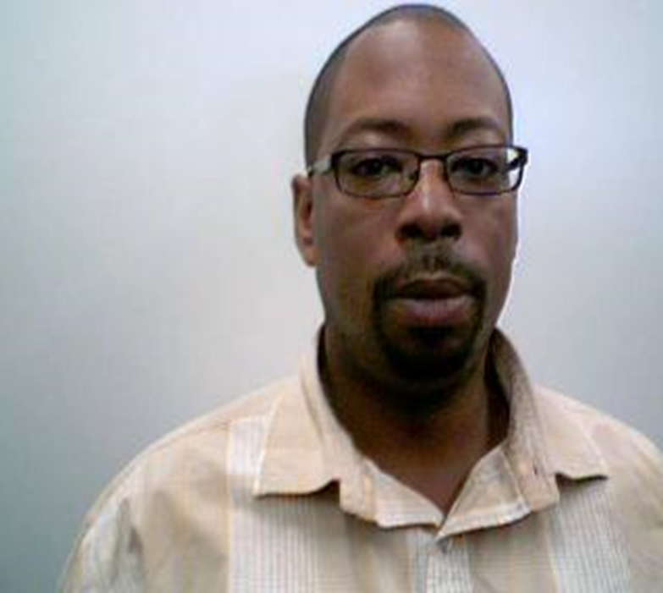

**January**

22nd PTO Meeting 6:30 p.m.

24th School Improvement Early Dismissal

**February**

12th PTO Meeting 6:00 p.m.

12th Black History Program 6:30 p.m.

17th President’s Day-No School

21st School Improvement-Early Dismissal 11:45 a.m.

26th Markham Park ISAT Rally 9:30 a.m.

**March**

3rd Pulaski Day-No School

7th Early Dismissal 1:30 p.m.

12th PTO Meeting 6:00 p.m.

26th Markham Park Family Read Night 6:30 p.m.

#### Markham Park School’s Newsletter Page 2





Welcome back to a new year! It’s hard to believe that we are already into January. The saying “Time flies when you are having a good time” really is true!

This month in math class we will be working on fractions! We are learning different approaches to naming sections and also practicing building our own fractions. The students are always working on explaining how they got their answers as well.

In reading we are continuing to focus on our comprehension skills. We are working on comparing and contrasting, drawing conclusions, and stating the main idea. We will also continue our phonics studies with our weekly spelling words.

The students have been busy working on expository essays as well as persuasive writings. Right now we are working on our district essay prompt which is explaining about how we can save water. Don’t be surprised if your child tells you to make sure the faucet is turned off!

So far it has been a great month and we are looking forward to many more!

Mr. Goodwin

What We’re Learning

**Reading/Language Arts:**

* Target Skills: Drawing Conclusions, Literary Elements, Inferring, Using Graphic Sources, Generalizing, Story Structure, and Important Ideas
* Writing: Fiction, Formal Letters, Plays, Persuasive/Informative District Essays
* Types of Verbs, Homophones, Prefixes

**Math-** Fractions: Basic understanding, benchmark fractions (halves, thirds, fourths, sixths, and eighths), equivalent fractions, comparing fractions, fractions on a number line, adding/subtracting fractions

**Science**- Understanding how living things interact and review various processes of the scientific method

**Social Studies**- Understanding communities; how they work and grow

**Handwriting**- Beginning to intermediate stages of cursive writing skills

Important to Know:

* Students should be working on science fair projects!
* Make sure students are utilizing I-Ready at home to strengthen various reading/math skills to enhance their individual growth
* We are low on the following supplies:

pencils, glue sticks, crayons, and markers. Donations would be greatly appreciated!

Thank you 3rd Grade parents for your continuous support!

Markham Park School’s Newsletter Page 3

# 3rd Grade-Mr. Goodwin

# 3rd Grade-Ms. Dearman